Emmanuel Vargas

CSE-140

February 16, 2021

Homework 2

1. File submitted to catourses, total instructions used to calculate A\*B was: 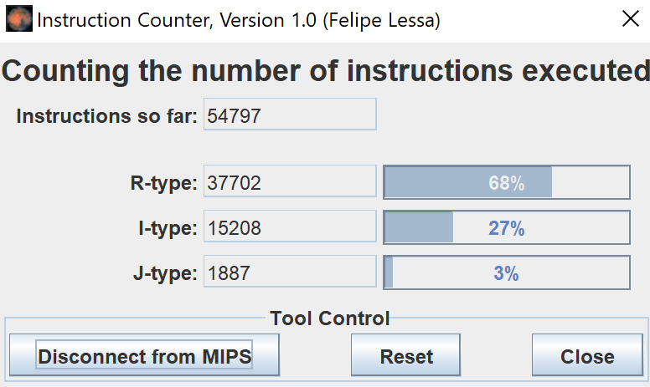
2. .
   1. Which processor has the highest performance in instructions per second?

Use formula: Performance = Clock Rate / CPI

For P1: 3Ghz / 1.5 cycles/instruction = 2 G instructions/s

For P2: 4Ghz / 2 cycles/instruction = 2 G instructions/s

Neither processor is faster, both processors have the same performance at 2 giga-instructions per second.

* 1. Find the new clock rate (CR) for both processors to bring CPU time down to 50 s.

First use the old CPU time and info for P1 to find instructions ran

CPU time = (n \* CPI) / CR

100 = 1.5n / 3GHz

n = 2 x 1011

Find new CPI’s if P1 increases by 10% and P2 by 20%

P1: 1.5 \* 1.1 = 1.65 cycles/instructions

P2: 2 \* 1.2 = 2.4 cycles/instruction

Find clock rate for P1 needed to obtain 50 second CPU time:

50 = 1.65(2 x 1011) / CR

P1 CR = 6.6 GHz

Find clock rate for P2 needed to obtain 50 second CPU time:

50 = 2.4(2 x 1011) / CR

P2 CR = 9.6 GHz